Guide to Hiking with the neoTrekk™ StackPack

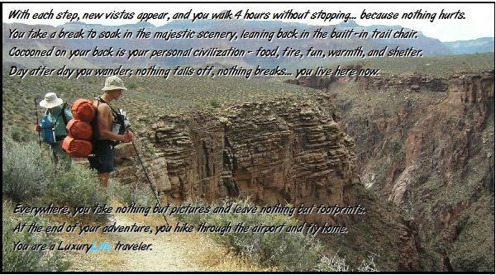
Don't let this big User Guide scare you! It’s for customers who love technical details. You can put your gear in the pack, put it on and just go hiking. It will fit pretty good. Questions: call 979-900-6280

Quick Start (if you are new to external frame packs)
1) The StackPack is designed to allow you to put no weight on your shoulders. If that is your goal, it is best that you wear a pair of hiking pants with an elastic waist band and keep your shirt outside your pants so you can pull the shirt down straight after putting the pack on to get rid of bunched-up shirttail fabric. The goal: NO pressure points. If you insist on wearing a belt and a bulky tucked-in shirt, we recommend that you first wrap your waist with a thin foam exercise belt pad and then put on your clothes.

2) For ultralight loads (<30lbs) the shoulder straps should not be tight so the weight is transferred to the Hook Belt. Make the shoulder straps just snug enough that they touch your chest with no pressure. The shoulder straps provide side-to-side stability; they don't need to bear weight for ultralight loads. If you need to carry a heavy load, add the mesh back panels and Hook Belt pad set to share weight between your shoulders and hips.

3) Don’t use the Front Hydration Pack on your first try. Load the backpack with about 25 lbs and get used to it alone for an hour or two of hiking around near the house. Then try the Front Pack with 3 bottles of water in it.

4) The only adjustment that will be new to you is the waist belt Logo Strap. See the instruction sheet that comes in the bag with the Hook Belt. If the waist belt is too small or too big, peel off the Logo Strap and re-stick it a few inches back toward the Hook or forward toward the front.

5) You will not pack your gear like you do in a typical internal frame pack:
- Don’t roll up items like sleeping pads and tents; fold into flat rectangles and stack into the barrel bag.
OR: just cram that tent into the Barrel Bag like you do with a down sleeping bag into a stuffsack.
- Avoid stuff sacks; they just make fitting everything in harder.
- Put everything inside the Barrel Bags, not tied outside. Heavy things tied outside can tear the Barrel Bags.
- The bottom two Barrel Bags should be stuffed tight so they stay round, not squished flat. That way the pack is very stable on your back.

6) The whole pack is designed to work great when worn kinda loosey-goosey like the old classic external frame packs. (But the Hook Belt will usually have to be tighter than what you’re used to.) Internal frame packs put many restraints on natural body movements. The StackPack does not inhibit your movements at all. Getting used to this loose feeling may take a few dozen miles. You will soon learn to walk naturally again, with grace and balance.
The neoTrekk™ StackPack

You can figure it all out without reading anything here. But thousands of miles of trail experience are condensed here to make your next trek much more fun. The StackPack is different from any other pack you have used in four important ways: 1) It weighs less… about 2.5 pounds; 2) Your gear will stay organized so you can find and use what you need when you need it, 3) it can be setup to put no compression on your spine or shoulders; and 4) you can customize your pack for your style.

The StackPack will not feel like an internal frame pack. The waist belt rides higher than normal and the pack weight rides low. If you are used to an internal frame pack, or an old-school external frame pack, your NeoTrekk™™ StackPack will feel strange for a while. Give yourself a few days of hiking time to adjust. But we did this for a good reason… mother nature designed your body to carry extra weight around the middle (...think... when people get fat, where does the body store it?). The bottom tube of the frame should be nested in your lumbar curve. The curves on the lower edge of the waist belt at each side should be right over the top of your pelvic arch (the ‘hip bone’); higher than a typical backpack belt.

At its most functional setting, the Hook Belt will probably be tighter than you’re used to with your old pack… since it is carrying the entire weight of your gear. But this compression around your middle supports your back and lets you hike longer (like those back belts you see Home Depot workers wearing). The waist belt has a pronounced conical geometry so gals can usually wear the waist belt looser and lower than guys.

How to Put On the Pack: Do One Shoulder – Set on the Hook – Do Other Shoulder.
First, put the Hook Belt on and snug it up. Stand in front of the pack as it stands on the ground (or stump, or table) and reach down thru the right shoulder strap and (1) hook your fingers under the frame shelf. Then grab the top of the right shoulder strap with your left hand and lift the pack all the way up and (2) set it down on your shoulder. Next, reach back with both hands and lift the frame shelf and (3) drop it onto the Hook. Now, (4) poke your left elbow outward under its shoulder strap until it’s on your shoulder. Now reach up beside your head with both hands and set the slider to the desired height. Last, adjust both shoulder straps to the desired length.

Inside, please. Put all your gear inside the Barrel Bags. Don’t strap your tent or sleeping bag outside onto the frame. This will cause problems with stresses and wear on the barrel bags and void the warranty. Plus, your gear can get trail damage and you look like an amateur. If you have to carry a tent or sleeping pad outside, it must go on the bottom, sitting on the frame shelf, with the barrel bags sitting on top of it. No gear should be carried between the barrel bags or on the top.

Barrel Bag Stuffing. You should pack soft items in the barrel bags next to your back… like clothes, pads, or rainfly. (if you are using the mesh back panels, this does not matter.) The barrel bags will press on your back a little if you really tighten the shoulder straps or if you hike hunched over. If you put a bear canister inside a barrel bag, use a thin foam liner to prevent the canister from wearing a hole in the fabric against the frame tubes.

Hook Belt Sizing: The Hook Belt logo strap can be stuck anywhere on the waist belt to fit waists/hips from 24” to 40”. The optional belt goes up to 54”. Remember, you don’t want to wear pants with a belt belt loops… this creates pressure points that can hurt. Elastic waistband hiking pants work great. A bulky shirt all bunched up under the pants can also make pressure points. If you are carrying a big load (over 30 lbs) we recommend that you wear high top boxer briefs or control-top panties to protect your skin from pressures points. If you are carrying 40 lbs or more, you will need to wrap your waist with foam padding, (like the neoprene exercise belt that is included when you order the Hook Belt pad set), then put your clothes on. This adds a huge comfort factor because it prevents clothing wrinkles from creating sore spots.

Shoulder Straps. The shoulder straps are designed to be worn loosely for weights up to 35 lbs. In this mode, they carry no weight, serving only to stabilize the pack. When using the Front Pack with 5 lbs or more of water and gear, it will pull the backpack forward just like the shoulder straps do; allowing you to make the shoulders straps totally loose and floppy. All the weight is supported by your waistline, nothing compressing your spine.

Toughness. Treat this pack more carefully than your old heavy pack… because of the ultralight fabric. The fabric is strong…you will never blow out a seam or tear the fabric while cramming gear into the barrel bag, but barbed wire and sharp rocks will do bad things. The Barrel Bag Velcro closure will never rip apart. The mounting straps to the frame will not rip out. But, compared to the typical cordura packcloth, the ultralight laminated fabric is easier to abrade. So we recommend that you treat the ultralight barrel bags like you treat your ultralight tent. For example, don't lean back against a tree trunk and slide down to the ground because your knees are sore.

Barrel Bags. If a barrel bag gets cut or punctured with a sharp object or thorns, etc, repair is easy with almost any sticky tape. Tent or sail repair tape works best. Clear packing tape works well too. Stick the repair tape on the shiny side of the fabric.

When overstuffing a barrel bag (like with a big fat sleeping bag) cram the gear in and then latch the two buckles. Now it will be easier to mate the Velcro. You will not tear anything no matter how hard you push or cram.

Telescoping Frame. The frame automatically telescopes to fit any torso length. The frame is constrained from coming apart by the two shoulder straps. You can unclip them at the bottom to take the frame slider out. You can reach back behind your head while hiking and pull the top bar up or push it down as you wish for comfort. The frame does not lock into place with any mechanism; it is designed to float up or down to remove weight from your shoulders and set the top of the shoulder straps to the position you like best. And you can change the height of the slider anytime while you hike. The shoulder straps slide along the top crossbar. You can adjust the width by sliding them together or apart. They will probably be the most comfortable at the widest position.

Hanging Stuff: You can hang wet socks, towels, etc from the strap behind the two buckles on each barrel bag, but do not hang more than one pound from each one. Don’t sew pockets or tabs to the barrel bags. It’s OK to hang things (like a hiking pole or dog lease from the frame tubes that stick up above the top tube.

Waterproofing: We seal the bartacks and seams with goop and/or spray silicone seal. If you get stuck hiking for hours in the rain you should re-spray when you get home and all dried out. Spray silicone seal over all the sewn seams inside and out. The barrel bags are designed to be waterproof in a rain storm while on your back or standing up on the ground. You can even float the pack across water with the frame in the water, barrel bag buckles up. Rain water can leak through the Velcro closures if you lay the pack frame-side on the ground. If your water or fuel bottle leaks inside a barrel bag, that liquid will stay inside that barrel bag. You can use a barrel bag as a water bucket to fetch water from a lake or stream. If you find rain leaking in, you may have a pinhole puncture or the stitching may be leaking. Apply some waterproofing spray inside and outside on all the thread lines and let it dry. A great test for waterproofness is during prep for your hike, pour a quart of water inside the barrel bag and hold it up to see if any drips appear near the frame Velcro loops or other seams. The rear bar tacks holding the Velcro straps that wrap around the frame are the places that can leak water if not sealed totally.

Waist Belt Rotation Adjustment for Unbalanced Loads: You can compensate if you packed up with more weight on one side and need to shift the pack sideways so the center of gravity feels right. Just rotate the entire waist belt to center the weight; you can do this while you are walking. Or, if you have some old injury, it might work better for you to shift the belt to one side a little. Experiment.

The Front Hydration Pack straps may sometimes fall off the frame pegs if you just loop them over. This happens mostly with tall hikers. To prevent this, see the picture of the Front Pack below and loop the straps over the peg, but also route the strap under the piece of top bar that sticks out horizontally.

Weight Limits: The pack is extensively trail tested at 30 pounds to insure a comfortable – actually… luxurious – fit and years of reliable service. But, if your body can carry more, the pack will work great up to 50lbs for most people (plus maybe 10 lbs in the Front Pack). Pressure points around your waist will develop if you are wearing pants with bumpy belt loops and seams. Carrying a lot of weight does not violate the warranty, it just might hurt. If you tighten up the shoulder straps you can shift some weight to shoulders and spine from your hips.

FrontPack Rules: Be careful how you load up the Front Pack. It will misbehave if you don't load it up so it is STIFF. If you are hiking and the StackPack insists on leaning to one side, it is almost always the pull from an unbalanced Front Pack, usually caused by using a water bladder that WILL flop to one side. We advise you to use three ordinary 24 ounce water bottles sitting straight up in the Front pack. No floppy bladder and no hoses to get scummy inside. Drink the middle bottle first, then drink equally from each side. Using three plastic or metal bottles also keeps the Front Pack stiff so it does not rock side to side.

Barrel Bag Packing Guide

You need to forget some habits that you learned when loading a typical ‘bottomless pit’ internal frame pack.
- Don’t roll up items like sleeping pads, tents, etc.
- Avoid stuff sacks; if you must, don’t stuff it tight.
- Put everything inside the Barrel Bags, not strapped on outside.

Basically, you do not want to roll your stuff into dense little cylinders because they will fit poorly together inside the NeoTrekk™ Barrel bags, wasting space and making it look all lumpy.

Since the pack Barrel bags are actually big stuff sacks, leave all those other stuff sacks at home and cut your load another ½ pound or so. So, how do you fit things into the Barrel bags? The secret is to FOLD; not roll. For instance, if you have a 24x76” Thermarest, don’t roll it up like normal. Fold the two ends towards the middle, then fold in half again. You will have a rectangle 19”x24” four layers high. Now fold this in half the other way to get a bundle about 12x19”. Now slide this into an Extra Large Barrel bag and let it fold open (which it wants to do). Now pack other gear in the middle, like your tent (also folded, not rolled), rain gear, etc.
You can cut a rectangle of cheap Coleman green 3/8" foam pad to line the barrel bag to prevent hard gear from wearing a hole in the fabric against the frame tubes. This makes the barrel bags look real nice and smooth. And you use those pads for sitting on, your kitchen table, sleep insulation, etc.

You should match the volume of gear to the barrel bags you use. A full complement of ultralight (and low volume) gear and a week of food will easily fit in three 17x10 Barrel bags as long as you don't use a synthetic sleeping bag. Get a down bag, they work much better. Store your food in one of those big clear plastic PETE jars from Sam's Club with pretzels, etc inside. (Odors do not seep through PETE plastic) As your food is used up the volume stays the same. The pack works better and looks better when the barrel bags are full and round. Other smellables (toothpaste, first aid, etc) can go into the big plastic jar. If you don’t use jars like this, then put the wet stuff in the bottom barrel bag and food, cooking, etc in the middle barrel bag.

You should fill one barrel bag (middle or bottom) with 'wet stuff', tent, sleeping pad, rain gear, dirty clothes, water bottles, etc. If you fold the sleeping pad into a rectangle and use it to line the outside of the barrel bag, it makes the bag look real nice. The LuxuryLite Cot can be stuffed into the center of your shelter after it is folded into a rectangle and put into the Barrel bag first and then opened like a taco shell to make a nice padded space for the Cot and other hard gear.

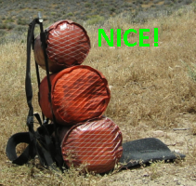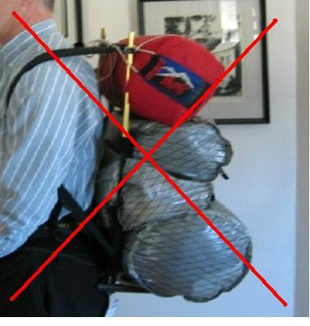

The pack on the left is filled with all the gear and food for a 4 day Grand Canyon trek. That is how the NeoTrekk™ Pack looks when the Barrel bags are filled the right way. (You can see the outline of the big Sam’s Club plastic jar in the bottom barrel bag.) The pack on the right is done wrong… a tent is lashed to the top bar, and the barrel bags are not filled right. Not good. The tent will fit in one Barrel Bag and the contents of the top two Bags will fit into one of them.

You should stuff the bottom barrel bag full to make a good foundation for the barrel bags above and to keep a nice round look. But you should segregate the wet stuff in one barrel bag; the food, stove, etc, in another; sleeping bag, dry clothes, etc in the top barrel bag.

Put Weight Up High or Down Low? The issue of where to carry the weight in a backpack is much discussed. The 'old school' theory from the 60s says to carry the weight up high. Today, there is a better way for most hikers. What has changed?
1) Typical loads today are one half of what they used to be when WWII surplus gear was popular. When you carried 60-70 lbs, some had to be way up high or you walked really humped over to stay centered over your feet.
2) Mother Nature designed us to carry extra weight around our waist (did you ever see an obese person with a skinny waist and big fat shoulders and head??). When you walk, with each step taken, you expend a bit of energy rebalancing your body. With pack weight up high, your center of gravity is way higher than your brain is used to, forcing your body to perform many more little muscle twitches with each step
3) When you wear the StackPack and Front Pack, your center of gravity with the pack on is not much different than with it off. So your muscles have to do less work to keep your body balanced and you will stumble or fall less.

On a long hike that can make a big difference. The StackPack puts the weight low where it is more natural for your body to carry it. You gain another advantage with the 10" barrel bags putting the weight much closer to your spine than a typical bulging pack that often sticks out 15" from your back. With the weight closer to your spine you walk naturally upright. Less fatigue, more fun.

BUT, some hikers are totally used to having their gear piled up high and want to continue with that geometry. We sell accessories like the BigLoad Package that adds height to your pack to match the layout of the traditional external frame pack, like you see in the movie ‘Wild’. You can have it your way.

Washing Your Pack

The shiny surface of the Barrel Bags does not hold dirt. The best way to clean is with Windex spray and paper towels. You can wash the Hook Belt and shoulder straps the same way. DO NOT put the barrel bags or belts in a dryer. Let them AIR DRY.

Pack Abuse

Many packers have old habits that are no problem for a backpack using 1000 denier cordura and weighing 8lbs. But these habits can cause problems for an ultralight two pound pack.
Don't...
... throw the pack down on the cactus and sit on it like a sack of feed.
... drag the pack up a cliff with a long rope.
... lean back against a tree and slide down to the ground.
... throw it in a pickup bed and pile the barbecue grill, dutch ovens, etc on top.
... toss it down over a 12 foot embankment so you can climb down easier.

PLEASE call or email if you have ANY problems getting a totally comfortable fit… 979 900 6280.
Front Pack Attachment Instructions

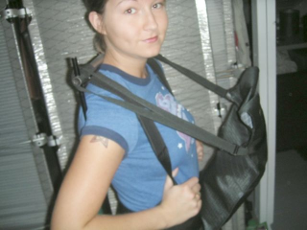

Hang the two straps over the posts at the top of the pack frame. Make sure the straps also go under the stub of the horizontal top tube, as shown in the photo. Length should be set to put the front pack at about a 45 degree angle.

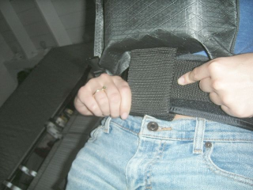

Push the beavertail down between your shirt and the belt; then up under the front pack. The water in the front pack will pin the end of the beaver tail in place. If the beavertail end keeps falling out, pull the Hook Belt strap loose and wrap it over the beavertail and stick it down again.
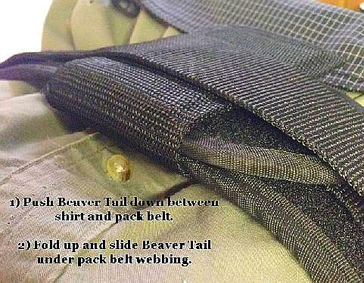

High Back Trail/Camp Chair

The Sit Pad has two positions: Folded in half under the bottom Barrel bag. This is how it is delivered. You can slide it out and fold down to make a Sit Pad… sit down on it and just lean back. Slide your butt fore and aft to set the lean angle of the pack frame. No stick or hiking pole or tree needed to prop up your pack at the right angle.

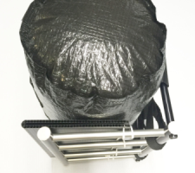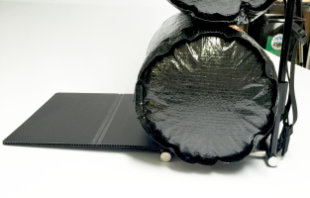

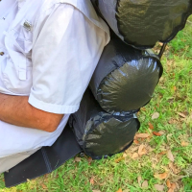

Guide to Flying with the NeoTrekk™ StackPack

The Telescoping Frame will compress down to less than 22” tall, legal for international air travel. For domestic air travel, most commercial carryon bags are larger than the official size of 22x14x9. The air crew is usually very lenient unless the flight is jammed. You will probably have no trouble traveling in the US with three 17x10" barrel bags on the frame.

Since US air regulations allow one carry on luggage item and one ‘personal’ item, you can use a fourth barrel bag as your personal item. … just tell the air crew that it is your ‘purse’, or diaper bag. If you’re a gal, they see a lot of bigger diaper bags. If you’re a guy, they will not pursue the issue. Once off the plane, attach the fourth barrel bag on top and hike to the hotel or your car with your hands free. Or use the AirPort Wheel Kit to roll to your car.
When the shoulder straps are extended to max length, the handle is 36" tall for comfortable wheeling through the airport.

When you must check your StackPack as luggage, fold up the Hook Belt and put it inside a barrel bag. Lay the pack with Bags up on a table and unclip the two shoulder straps at the bottom. Pull the straps sideways and put them down over the Barrel Bags and click the buckles back around the Belt Tube of the frame. Then snug up the upside-down shoulder strap adjusters. Tuck the shoulder belt strap loose ends in between the nearest Barrel Bag Velcro closure to keep them from catching on conveyor belt equipment. Be sure to have a name tag on the pack.

Grand Canyon Rim to Rim Hike 2006


